Whitewater Rafting Site – Planning Document

By: Malvern Kwashira

# Logo

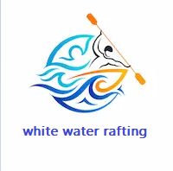

# Color Palette

|  |  |
| --- | --- |
| Label | Color Code |
| Primary Color | #1B4965 |
| Secondary Color | #CAE9FF |
| Accent 1 Color | #5FA8D3 |
| Accent 2 Color | #62B6CB |

Color Palette URL: https://coolors.co/1b4965-cae9ff-5fa8d3-62b6cb

# Typography

|  |  |
| --- | --- |
| Font Label | Font Name |
| Heading Font | Montserrat |
| Text Font | Open Sans |